1. Microcontroller Analysis & Case Studies

1.1 Comparative Analysis: Arduino Nano, ESP32, ESP8266, and STM32 Microcontrollers

Feature | Arduino Nano (ATmega328P) | ESP8266 (NodeMCU) | ESP32 (WROOM-32) | STM32 (ARM Cortex-M Series)
Architecture | 8-bit AVR | 32-bit Tensilica L106 | 32-bit Xtensa Dual-Core | 32-bit ARM Cortex-M
Clock Speed | 16 MHz | 80 / 160 MHz | 240 MHz | 72 MHz to 480+ MHz (Varies)
Analog Pins (ADC) | 8 (10-bit resolution) | 1 (10-bit resolution) | 18 (12-bit resolution) * | Up to 24+ (12-bit or 16-bit)
Hardware Timers | Basic (3 timers) | Software/Limited | Advanced (High Res) | Industrial Grade (Highly Precise)
LFR Capability | Creates a processing bottleneck; struggles to compute PID and read multiple sensors at 1-2 ms loop frequencies. | Poor for LFRs. Only 1 analog pin makes it impossible to read IR sensor arrays without an external multiplexer. | Excellent processing power. *Note: Its internal ADCs are notoriously non-linear, often requiring external ADCs for precise IR tracking. | The gold standard for professional racers. Provides highly deterministic, high-speed execution without wireless stack overhead.

1.2 Case Study: Architectural Advantages of STM32 Selection in Hayabusa2.2

Why Hayabusa2.2 Uses the STM32 (STM32F405)
The Hayabusa2.2, built by Hayato Nomura, is an elite championship-winning robot. It utilizes a 32-bit ARM-based architecture, specifically the STM32F405. This choice is driven directly by the extreme physics of its components:
- High-Frequency PID Loop Requirements: The robot takes corners at a maximum turning velocity of 2.0 m/s. To manage this smoothly, it must run a high-frequency PID loop inside the 32-bit ARM Cortex architecture. The STM32 provides incredibly fast and deterministic (jitter-free) execution times, meaning the control loop runs at exact millisecond intervals without being interrupted by background processes.
- Sensor Density: It utilizes a 13-element infrared line-sensor array. The STM32 has ultra-fast, multi-channel hardware ADCs that can poll all 13 sensors virtually instantaneously compared to an Arduino.
- Advanced IMU Integration: Hayabusa2.2 uses a specialized TDK InvenSense ICM-20648 gyro sensor, which has a dedicated Embedded Motion Processor (DMP) to handle severe vibrations from the suction fans and high-RPM tires. The STM32's fast SPI/I2C buses can communicate with this advanced IMU much faster and more reliably than slower 8-bit boards.

1.3 Case Study: Component-Driven Selection of ESP32 in Semreh

Why Semreh Uses the ESP32-WROOM-32
The Semreh V2, developed by Tamandutech, employs a highly complex and unusual component stack for a line follower. It is powered by the ESP32-WROOM-32 module.
- Handling Multiple Complex Subsystems: The Semreh robot manages an incredible amount of hardware simultaneously. It drives two 1020 Coreless Motors for locomotion and interfaces with an ESC 4in1 BlHeli 15A to control four separate Brushless Motors (1103 8000kv) dedicated entirely to generating artificial downforce. The dual-core 240MHz processor of the ESP32 provides the sheer computational muscle needed to manage these disparate motor systems simultaneously.
- The External ADC Workaround (MCP3008): Notice that while the ESP32 has its own analog pins, the Semreh team deliberately incorporated an external ADC - MCP3008 into their hardware to read their 8x QRE1113 main sensors. This is a genius engineering decision: the native ADCs on the ESP32 are known in the engineering community to be slightly non-linear and noisy. By offloading the sensor reading to a dedicated, highly accurate external MCP3008 chip, they get the massive processing power of the ESP32 combined with flawless analog sensor readings.
- Custom H-Bridge Management: Because the extreme current draw of the 1020 coreless motors caused their standard TB6612 motor driver to trip, they had to build a custom high-current H-Bridge using RZ7886 ICs. The ESP32's high-resolution PWM controllers allow for incredibly precise throttling of these raw, powerful coreless motors.

2. Line Follower Robot (LFR) Processing Capabilities & Component Integration

2.1 Decoupling LFR Capability Terms: Loop Frequency, ADC Linearity, and Deterministic Execution

2.2 Microcontroller Selection Matrix for High-Speed Line Followers

2.3 Component Stack Architecture: Integrating Processing Units with Sensors, Motors, and Suction Fans

2.4 Alternative Hardware Stacks for Custom LFR Optimization

1. Arduino Nano: "The Processing Bottleneck"
- What it means: The Nano is simply too slow to "think" at racing speeds. By the time it reads the line, runs the PID math, and tells the motors to turn, the robot has already driven past the curve and flown off the track. A 1-2 ms loop frequency means the brain updates 500 to 1,000 times a second; the Nano struggles to do this when managing multiple sensors.
- Why use it: It is perfect for prototyping, learning control logic, and building foundational skills before dealing with complex 32-bit architecture.
- Ideal Component Stack:
  - Motors: N20 Gear Motors (Low speed, 300 to 600 RPM).
  - Driver: L298N or TB6612FNG.
  - Sensors: A standard 8-channel IR array.
  - Suction Fan: Do not use. The Nano cannot react fast enough to utilize the grip an active downforce system provides.
- Can it use other stacks? You can plug in 1000 RPM motors, but the bot will aggressively wobble or crash because the Nano cannot calculate the corrections fast enough to tame the speed.
2. ESP8266 (NodeMCU): "The Blind Spot"
- What it means: It is practically blind for this specific task. To follow a line precisely, you need an array of 8 to 16 analog infrared sensors. The ESP8266 only has one analog pin.
- Why use it: Generally, you should not use this for a competitive line follower. It is designed for Wi-Fi and IoT projects, not high-speed robotics.
- Ideal Component Stack:
  - Sensors: If forced to use it, you must add an external "multiplexer" chip (like a 74HC4067) just so that single pin can rapidly switch between looking at 8 different sensors.
  - Motors/Driver: Standard N20s and a TB6612FNG.
- Can it use other stacks? Yes, but the hardware gymnastics required just to make it read a sensor array make it an impractical choice for racing.
3. ESP32: "The Powerful Multi-Tasker"
- What it means: The ESP32 is incredibly fast and has two cores, meaning it can think about multiple complex things at once. However, its built-in Analog-to-Digital Converters (ADCs)—the parts that read the IR sensors—are notoriously noisy and inaccurate.
- Why use it: It is the best choice if you are building an overly complex robot that manages entirely separate subsystems simultaneously, or if you want to send real-time telemetry data to your laptop via Wi-Fi/Bluetooth while it races.
- Ideal Component Stack:
  - Motors: 1020 Coreless drone motors for extreme acceleration.
  - Driver: Custom high-current H-Bridge (RZ7886) to handle the massive power draw of coreless motors.
  - Sensors: Dual Array (16 front, 8 mid). Crucial addition: You must pair the sensors with an external ADC chip (like the MCP3008) so the ESP32 can "see" the line clearly.
  - Suction Fan: Brushless drone motors driven by an ESC (Electronic Speed Controller) to generate massive downforce.
- Can it use other stacks? Absolutely. It can run standard N20 motors beautifully, but using an ESP32 for a standard bot is often overkill unless you need its dual-core processing.
4. STM32: "The Focused Racer" (The Best Fit)
- What it means: The STM32 is a laser-focused, industrial-grade brain. It doesn’t get distracted by Wi-Fi or Bluetooth stacks in the background. It reads high-density sensor arrays instantly and executes heavy PID math flawlessly, making it the undisputed gold standard for professional micromouse and line-following competitions.
- Why use it: If your goal is pure speed, tight cornering, and maximum stability on the track, this is the board. It provides the deterministic (jitter-free) timing required for high-frequency control loops.
- Ideal Component Stack:
  - Motors: High-speed 12V N20 Gear Motors (1000 RPM) or premium Maxon DCX motors.
  - Driver: TB6612FNG utilizing the "Short Brake" mode for instant deceleration.
  - Sensors: Dual Array setup (16-channel look-ahead boom + 8-channel intersection array).
  - Gyro: TDK ICM-20648 to handle vibrations.
  - Suction Fan: High-speed Electric Ducted Fan (EDF) mechanism to artificially multiply tire grip.
- Can it use other stacks? Yes, it will run lower-tier components perfectly, but its true potential is unlocked when paired with a high-RPM, high-downforce setup.
The Verdict for Your New Build: If you want to build a highly competitive, lightning-fast robot, the STM32 is your best fit. It completely eliminates the processing bottlenecks of 8-bit boards and provides the raw calculation speed necessary to tame 1000 RPM motors and an active suction fan.

3. Motor Encoders in High-Precision Odometry

3.1 Core Mechanics: Understanding Encoders and Their Role in LFR Navigation

What are Encoders?
An encoder is an electromechanical sensor attached to a motor shaft or a wheel. It converts the physical rotation of the motor into a series of digital electrical pulses. By counting these pulses, the robot's brain can calculate exactly how fast the wheel is spinning (RPM), what direction it is spinning, and the exact distance the robot has traveled.
Why are Encoders Used in High-Speed LFRs?
In basic line following, robots just react to what the front sensors see in real-time. In world-class competitions, robots use encoders to transition from "reacting" to "predicting."
- Mapping and Memorization (The Search Lap): In elite leagues like the All Japan Robotracer contest, robots perform a slow "search lap" first. They use encoders to map the exact length of every straightaway and the radius of every curve. On the second "fast run," the robot uses this memorized encoder data to pre-calculate maximum theoretical speeds for every millimeter of the track.
- Straight-Line Velocity Control: No two motors are perfectly identical; one will always spin slightly faster than the other at the same voltage, causing the robot to drift. Encoders measure the exact RPM of both wheels independently. The microcontroller then uses a separate PID loop to perfectly synchronize their speeds, ensuring the robot drives dead straight without relying entirely on the line sensors.
- Precision Braking: By tracking exact distances, the robot knows exactly when to slam on the brakes using the motor driver's "Short Brake" mode before a sharp 90-degree turn or intersection, preventing overshoot.

3.2 Microcontroller Constraints and Interrupt Demands for Encoder Processing

Microcontroller Requirements for Encoders
No microcontroller strictly requires an encoder to function, but processing encoder data requires specific hardware capabilities.
The STM32 and ESP32 are required for effective encoder use. High-speed motors generate thousands of encoder pulses per second.
- An 8-bit board like the Arduino Nano gets completely overwhelmed trying to count these rapid pulses while simultaneously reading a 16-sensor IR array and calculating PID math. It lacks the advanced hardware timers to handle this gracefully.
- A 32-bit ARM Cortex board like the STM32 features highly precise, dedicated hardware timers. It can count millions of encoder pulses in the background without interrupting the main PID control loop, making it the industry standard for mapped racing.
- The ESP32 also has excellent high-resolution hardware timers and a dual-core architecture capable of managing encoder interrupts effortlessly.
Encoder Mounting Challenges: Depending on your motor choice, adding encoders can be a mechanical challenge. While many N20 gear motors come with magnetic encoders pre-attached to the rear shaft, high-performance drone motors do not. For instance, when utilizing 1020 coreless motors, there is often no native slot or shaft to attach wheel encoders easily. This requires designing custom mounting solutions, such as bonding standard Pololu encoders directly to the chassis and linking them to the main wheel axis via an additional gear.

3.3 Intercomponent Relationships: Encoders, Processors, and Feedback Loops

Relationship with Other Components (The Kinematic Loop)
Encoders do not operate in isolation; they are a critical piece of the robot's closed-loop sensory system.
- IR Sensor Array (Lateral Data): The front line sensors tell the microcontroller how far left or right the robot is drifting off the line.
- Encoders (Longitudinal Data): The encoders tell the microcontroller how fast the robot is moving forward and exactly how far it has traveled down the straightaway.
- Gyroscope/IMU (Rotational Data): The IMU (like the ICM-20648) tells the microcontroller the exact angle the robot is pivoting during a turn.
- Motor Driver (The Muscles): The microcontroller takes the data from the IR sensors, Encoders, and Gyro, computes the grand PID error, and sends a highly specific PWM signal to the motor driver (e.g., TB6612FNG or RZ7886). The driver then adjusts the voltage to the motors to correct the path instantly.

4. Inertial Measurement Units (IMUs) & Encoder Hardware Interfacing

4.1 Functional Role and Working Principles of Gyroscopes/IMUs in LFR Stability

What is its exact use in an LFR?
An IMU acts as the robot's inner ear. While the IR sensors tell the robot where the line is, the IMU tells the robot exactly what its physical body is doing in space. Its primary use in an LFR is measuring the exact angle of a turn (Yaw).
The Working Mechanism
Inside an IMU chip (like an MPU6050 or ICM-20648) are microscopic vibrating structures called MEMS (Micro-Electro-Mechanical Systems). When the robot turns, the Coriolis force causes these microscopic structures to bend. The chip measures this microscopic bending and turns it into electrical signals.

4.2 Kinematic Computations: Translating Raw IMU Data into Navigation Corrections

What data does it send & what is computed?
- The Data Sent: The gyroscope sends the robot's Angular Velocity—specifically, how fast it is rotating in Degrees Per Second (°/s).
- The Computation: The microcontroller takes this speed and calculates the integral over time θ = $\int{w dt}$
  - Simple terms: If the gyro says "I am spinning right at 100 degrees per second," and it does that for 0.5 seconds, the microcontroller calculates: 100 * 0.5 = 50 degrees. The robot now knows it is exactly 50 degrees off its original straight path.

4.3 Necessity Assessment: The Impact of Eliminating IMUs from High-Performance Architectures
How it helps the bot (Why it's actually used)
- Beating "Tire Slip": If your robot hits a dusty patch on a sharp corner, the wheels might spin fast, but the robot slides sideways. Encoders would think the turn was successful, but the Gyro knows the truth because it measures the actual rotation of the chassis.
- Missing Lines & Intersections: If the robot hits a 10cm gap in the line, the IR sensors go blind. The Gyro takes over instantly, using its heading data to hold the robot perfectly straight until it finds the line again.
Is it necessary? What happens without it?
- For a standard LFR: No, it is not necessary. If you are just tracking a continuous black line, PID + IR sensors are enough.
- Without it: If your robot overshoots a 90-degree turn and flies off the line, it gets totally lost and spins in circles trying to find the line.
- With STM32 / ESP32: Yes, it is heavily recommended to use a 32-bit MCU if you use an IMU. To get accurate angles, the math requires floating-point calculations and complex noise filters (like a Kalman filter) running hundreds of times a second. An Arduino Nano will choke on this math.

4.4 Hardware Interfacing: Pinout and Wiring Configurations for Encoder-Based Motors

Encoder-Based Motors & Wiring
When you buy an N20 motor with an encoder, you will notice it has 6 pins instead of the usual 2. This confuses many builders because motor drivers only have 2 outputs per motor.
How the connections are done
You must "split" the wiring. The motor power goes to the driver, but the encoder data goes directly to the brain.
- M+ (Motor Power 1): Connects to Motor Driver (e.g., A01 on TB6612).
- M- (Motor Power 2): Connects to Motor Driver (e.g., A02 on TB6612).
- VCC (Encoder Power): Connects directly to the Microcontroller's 3.3V or 5V pin.
- GND (Encoder Ground): Connects directly to the Microcontroller's GND.
- Channel A (Data): Connects directly to a Microcontroller Digital/Interrupt pin.
- Channel B (Data): Connects directly to a Microcontroller Digital/Interrupt pin.
Note: The motor driver NEVER touches the encoder data wires.

4.5 Internal Motor Mechanisms and Feedback Loop Execution
Internal Mechanism & Data Handling
- The Mechanism: Attached to the back of the motor shaft is a tiny magnetic disc. Behind it is a Hall-effect sensor chip. As the motor spins, the magnets spin over the sensor.
- The Data Sent: The encoder sends two rapid digital square waves (Channel A and Channel B) to the microcontroller. Because they are slightly out of phase (offset), the microcontroller reads them to determine two things:
  - Speed/Distance: Counting the number of pulses ("ticks") tells you exactly how far the wheel moved.
  - Direction: Checking whether Channel A goes high before Channel B (or vice versa) tells the microcontroller if the wheel is spinning forward or backward.
- The Internal Reaction: The microcontroller compares the desired speed against the actual encoder speed. If the left motor hits a bump and slows down, the encoder reports fewer ticks. The MCU's speed PID loop instantly reacts by telling the motor driver to increase the PWM duty cycle to the left motor.

4.6 Optimal Hardware Ecosystems: Microcontroller, Motor, and Driver Combinations

The Best Fits & Hardware Combos
Combo 1: The Championship Standard (Best Overall Fit)
- MCU: STM32 (e.g., STM32F411 "Black Pill").
  - Why: The STM32 has dedicated "Quadrature Encoder Hardware Timers." It counts the thousands of encoder ticks automatically in the background without using up CPU processing power.
- Motor: 12V N20 Gear Motor (600 - 1000 RPM) with attached Magnetic Encoders.
- Motor Driver: TB6612FNG.
  - Why: It allows for "Short Brake" mode, allowing the STM32 to snap the motors to a halt accurately using the encoder distance data.

Combo 2: The Raw Power Alternative
- MCU: ESP32.
  - Why: Dual-core architecture easily handles high-frequency encoder interrupts via its PCNT (Pulse Counter) module.
- Motor: 1020 Coreless Motors. (Note: These don't usually come with encoders; you have to physically glue an optical encoder wheel to the custom gearbox).
- Motor Driver: DRV8833 or RZ7886.
  - Why: The TB6612FNG will burn out trying to supply the massive current spike of a coreless motor. The DRV8833 handles lower voltage/higher current bursts better, and custom RZ7886 modules are industrial grade.
Other Motor Driver Alternatives:
- L298N: Too bulky, too much voltage drop. Do not use for competitive LFRs.
- DRV8874: An incredibly modern, single-channel H-bridge (you'd need two). It has built-in current sensing, meaning the microcontroller can actually detect if the wheel is jammed against a wall without even looking at the encoder. It works beautifully with both STM32 and ESP32.

5. Advanced Kinematics: PID Tuning, Actuators, Drivers, and Suction Dynamics

5.1 Mitigating Integral Windup in Dynamic Cornering: Gyroscope-Assisted PID Compensation
The Gyroscope and the "Integral Term" Problem
Short Answer: No, adding a gyroscope will not solve the Integral ($I$) term problem for your line-following loop. You should still use a PD (Proportional-Derivative) controller for tracking the line.
The Detailed Physics: The Integral term works by accumulating past errors over time to eliminate "steady-state error" (e.g., if a drone is hovering but a constant wind is pushing it left, the $I$ term builds up a permanent rightward correction).
In a line follower, your track is constantly curving. The error is supposed to fluctuate wildly from positive (turning left) to negative (turning right). If you use an $I$ term, the robot will "remember" a long sweeping left turn. When it suddenly hits a sharp right turn, that accumulated left-turn "memory" will violently fight the necessary right-turn correction, causing the bot to oscillate and crash.

5.2 Comparative Performance Evaluation: N20 Motor Variants and Coreless Drive Systems

Motor Specs | Torque/Acceleration | Top Speed (approx) | Best Use Case
12V N20 (600 RPM) | High. Accelerates quickly out of corners. | Moderate (~1.0 m/s) | Complex, tight mazes with lots of 90° turns.
12V N20 (1000 RPM) | Moderate. | High (~2.0 m/s) | Standard competitive LFR racing.
12V N20 (1000 RPM) w/ Encoder | Moderate. Allows precise RPM tracking. | High (~2.0 m/s) | Best Overall. Allows straight-line synchronization and precise braking.
Pololu 6V N20 (3000 RPM) | Extremely Low. Will likely stall under weight. | Extreme (If it can move) | Not recommended for direct-drive LFRs without extreme gear reduction.

5.3 Actuator-Processor Matching: Selecting Motors for STM32 and ESP32 Platforms

The Best Fit & Microcontroller Combo: STM32 + 12V N20 1000 RPM with Encoders is the absolute best fit.
Why: 1000 RPM hits the "sweet spot" for LFR kinematics. The STM32 features highly precise, dedicated hardware timers that can count the thousands of encoder pulses automatically in the background. An ESP32 can also handle this, but the STM32 provides a much cleaner, jitter-free execution environment for the PID control loop without wireless stack overhead.

5.4 Motor Driver Benchmark: TB6612FNG, DRV8833, and RZ7886 Comparison

Motor Driver | Max Continuous Current | Braking Mode | Compatibility | Verdict
TB6612FNG | 1.2A (3.2A Peak) | Short Brake Mode | N20 Motors | Best for N20s. Short Brake mode allows instant deceleration without overshooting.
DRV8833 | 1.5A (2.0A Peak) | Slow/Fast Decay | N20 Motors | Good, but the TB6612FNG's braking physics are generally preferred for LFRs.
RZ7886 | ~13A Peak | Aggressive | Coreless/Drone Motors | Overkill for N20s. Only use this if you upgrade your drive wheels to 1020 coreless drone motors.

5.5 Suction Dynamics: Integrating 8520 Coreless Motors for Downforce Generation

Implementing the 8520 Coreless Motor (Suction Fan)
The 8520 coreless brushed motor is a micro-drone motor. Integrating it as a suction fan to multiply your tire's normal force ($N_{total}$) without adding mass is how you reach competition-winning speeds. However, it introduces several massive engineering hurdles.
1. The Working Mechanism: You will mount the motor vertically through the chassis. Attached to the shaft will be a 3D-printed (PETG) centrifugal impeller. Below the chassis, you must create a "skirt" (often made of thin Teflon or Kapton tape) that hovers roughly 1mm above the track. The impeller violently evacuates the air inside this skirt, creating a pressure differential ($\Delta P = P_{atm} - P_v$) that sucks the robot down onto the floor.

5.6 Electrical Safeguards: Managing High Current Draw and Inductive Spikes in Suction Fans

2. The Critical Voltage Problem:
- Your N20 motors and TB6612FNG run optimally on a 3S LiPo (11.1V - 12.6V).
- An 8520 coreless motor is designed for a 1S LiPo (3.7V - 4.2V).
- The Danger: If you connect the 8520 to your main 12V battery line, it will instantly burn out and potentially catch fire.
3. Electrical Connections & Current Draw:
At 3.7V, an 8520-motor spinning an impeller under load can draw 2.5A to 4.0A continuous. You absolutely cannot power this directly from the microcontroller or the TB6612FNG.
The Solution (How to wire it):
- Separate Power Regulation: You must either use a heavy-duty Step-Down Buck Converter (capable of at least 5A) to drop your 12V battery down to 3.7V, OR carry a separate, tiny 1S LiPo battery specifically for the fan.
- MOSFET Switch: To control the fan with your STM32/ESP32, you need an N-Channel Logic Level MOSFET (like an IRLB8721 or IRLML2502).
  - Gate: Connected to an STM32 PWM pin.
  - Drain: Connected to the motor's negative wire.
  - Source: Connected to the common Ground.
  - (Note: Always place a flyback diode across the motor terminals to prevent voltage spikes from frying your MCU).
4. The Vibration Problem: Spinning a 3D-printed piece of plastic at 40,000+ RPM will create intense, high-frequency vibrations. If you are using a cheap MPU6050 gyro, this vibration will completely blind the sensor, filling your PID loop with garbage noise. This is exactly why top-tier bots like Hayabusa2.2 use the TDK ICM-20648—it has built-in hardware dampening specifically to survive this exact scenario. Ensure your impeller is perfectly balanced (often done by lightly sanding the heavier blades) before running it at full speed

6. Power Management: Energy Storage and Regulation Architectures

6.1 Battery Chemistry Selection: Voltage, Capacity, and C-Rating Analysis for LFR

Batteries (Lithium Polymer - LiPo)
For LFRs, weight is your enemy, but voltage is your speed limit. You must balance a small footprint with immense power delivery.
LiPo Terminology for LFRs
- Voltage (S Rating): Defines the top speed of your motors. A single LiPo cell (1S) is 3.7V nominal. 2S is 7.4V. 3S is 11.1V.
- Capacity (mAh): Determines runtime and heavily influences weight. High-speed runs last seconds, so large batteries (like 1000mAh) are dead weight.
- C-Rating (Discharge Rate): This is the most critical metric. It dictates how much continuous current the battery can safely dump into your motors without experiencing "voltage sag."
  - Formula: $Max \, Current \, (A) = \frac{Capacity \, (mAh)}{1000} \times C\text{-}Rating$

Battery Type | Nominal Voltage | Weight (Approx) | Best Use Case
2S LiPo (300-450mAh) | 7.4V | ~20g - 30g | Slower, highly technical mazes using 6V motors.
3S LiPo (300-350mAh) | 11.1V | ~35g - 45g | Standard Racing. Perfect for driving 12V N20 motors to their physical limits.
Dedicated 1S LiPo (150-250mAh) | 3.7V | ~5g - 10g | Suction Fans. Often used in addition to a 2S/3S to power a 3.7V coreless fan motor, isolating electrical noise.

6.2 Voltage Regulation: Buck and Boost Converter Topologies for Stable Logic Power
Buck Converters (Step-Down Voltage Regulators)
Your battery puts out 11.1V, but your microcontroller, sensors, and suction fan will instantly fry if they receive more than 5V. Buck converters efficiently chop the high voltage down to a usable level.
Buck Converter Comparison
Converter Model | Max Continuous Current | Size / Weight | Efficiency & Heat | Verdict for LFR
LM2596 | ~2.5A (3A Peak) | Bulky / ~14g | Good, but the large inductor and capacitors add too much mass. | Not Recommended. Too heavy and raises the Center of Mass.
MP1584EN | ~2.0A (3A Peak) | Very Small / ~3g | Excellent. Can run at high frequencies. Will run hot near 2A. | Best Overall. The industry standard for lightweight robotics logic circuits.
Mini-360 | ~1.0A (1.8A Peak) | Ultra Micro / ~1g | Great for low loads. Will burn out if powering heavy loads. | Good for isolated logic (MCU + Sensors only). Cannot power motors.

6.3 System Interconnections: Power Distribution Networks (PDN) for Actuators and Logic

Component Connections
- Main Battery (11.1V) Connects directly to the Motor Driver's VMOT or VCC pin (for the N20 drive motors).
- Main Battery (11.1V) Connects to the IN+ of the Buck Converter.
- Buck Converter OUT+ (Tuned to 5.0V) Connects to the Microcontroller VIN/5V pin, and the VCC of your IR Sensor Array.

6.4 Reference Architecture 1: Powering an STM32 "Black Pill", TB6612FNG, and 12V N20 1000RPM System

Combo 1: The High-Speed Precision Racer (Best Fit)
Hardware: STM32 "Black Pill" | TB6612FNG | 12V N20 (1000rpm w/ encoders) | 8520 Coreless Fan. Goal: Maximum linear speed, perfect tracking, and high downforce.
- Primary Battery: 3S LiPo (350mAh, 70C). * Why: 12V is required to hit the 1000rpm top speed of the N20s. A 70C rating ensures that when the motors stall or brake instantly, the voltage does not drop.
- Logic Buck Converter: Mini-360 or MP1584 (Tuned to 5V).
  - Why: The STM32 is incredibly power-efficient. It, along with the IR sensors and TB6612FNG logic pins, will draw less than 0.5A combined.
- Suction Fan Solution (The "Dual Battery" Trick): * Instead of using a heavy LM2596 to step 12V down to 3.7V, use a separate, dedicated 1S LiPo (250mAh, 30C) strictly for the 8520 motor.
  - Connection: Connect the 1S battery directly to an N-channel Logic Level MOSFET (like IRLB8721). The STM32 sends a PWM signal to the MOSFET gate to turn the suction fan on and off.
  - Why: This saves the weight of a heavy buck converter, completely isolates the STM32 from the severe electrical noise generated by the 8520, and guarantees the fan gets the exact voltage it needs.

6.5 Reference Architecture 2: Powering an ESP32, TB6612FNG, and 12V N20 600RPM System

Combo 2: The Torquey Maze Solver
Hardware: ESP32 | TB6612FNG | 12V N20 (600rpm) | 8520 Coreless Fan. Goal: Slower top speed but high torque for navigating highly complex, sharp-cornered mazes.
- Primary Battery: 3S LiPo (450mAh, 50C).
  - Why: 12V is still required. We bump the capacity slightly to 450mAh because the ESP32's dual-core architecture draws significantly more quiescent current than the STM32.
- Logic Buck Converter: MP1584 (Tuned to 5V).
  - Why: Do not use the Mini-360 here. The ESP32 can have sudden current spikes (especially if Wi-Fi or Bluetooth is accidentally left active in the code) that will trip a smaller regulator. The MP1584 provides a safe 2A continuous overhead.
- Suction Fan Solution: * Again, use the dedicated 1S LiPo + MOSFET approach.
  - Why: If you absolutely refuse to use two batteries, your only option is to use a large LM2596 buck converter tuned to 3.7V to power the fan from the main 3S battery. However, this adds ~14g of weight high up on the chassis, raising your Center of Mass and making the robot more likely to tip over in corners.

STM32F411 Microcontroller
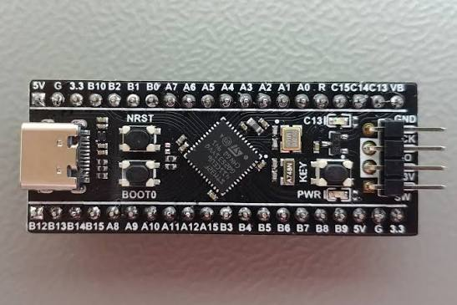

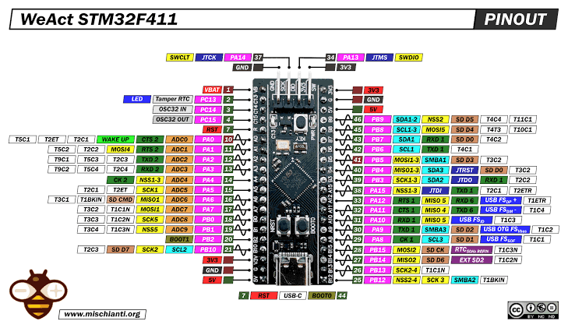
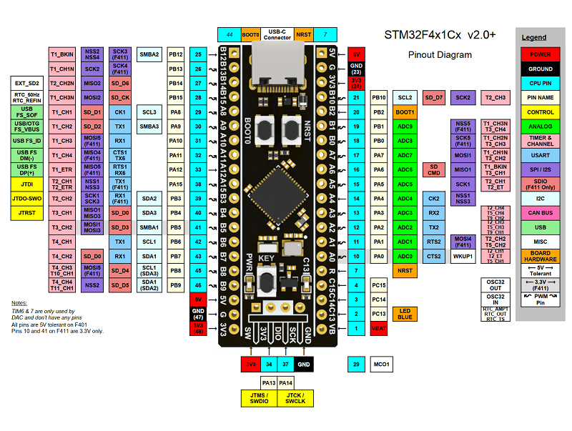
Take Reference for More details - https://stm32-base.org/boards/STM32F411CEU6-WeAct-Black-Pill-V2.0.html
Buying Link - https://share.google/8uT6CMw8DaNKjMOfd
https://share.google/yJcCNVwCj30VvOsUJ

Motor Driver – TB6612FNG

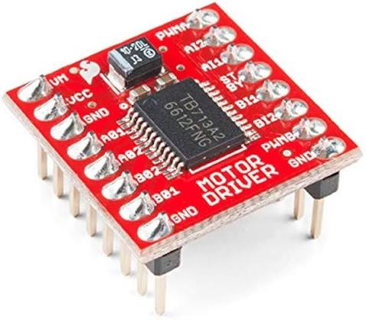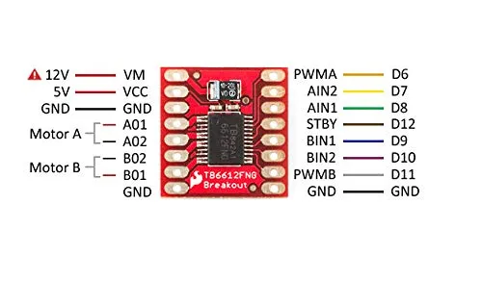

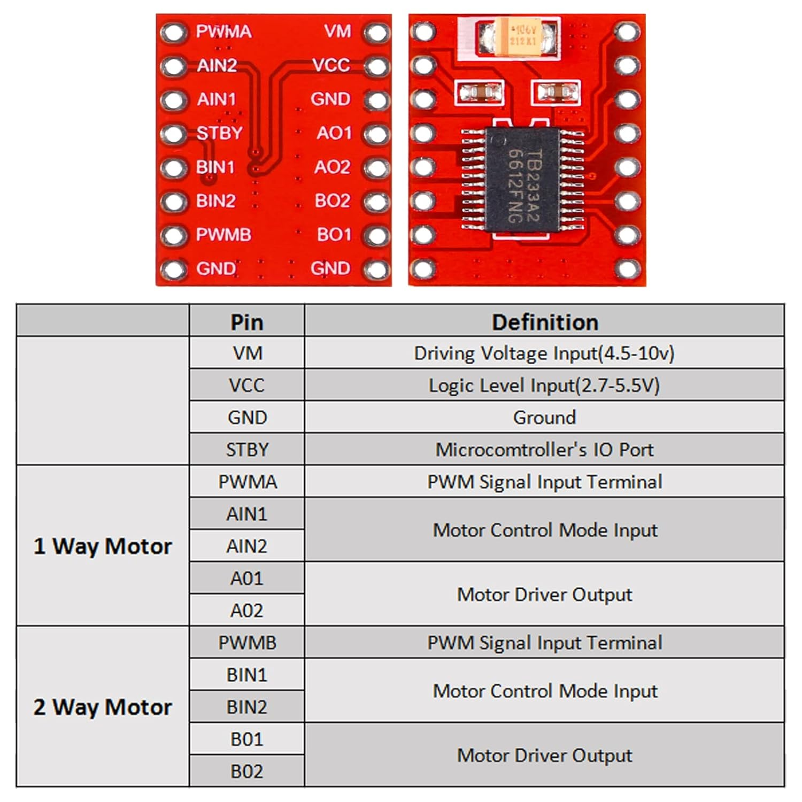
Reference - https://cdn.sparkfun.com/datasheets/Robotics/TB6612FNG.pdf
Buying Link - https://quartzcomponents.com/products/tb6612fng-dual-dc-motor-driver-module
https://robu.in/product/motor-driver-tb6612fng-module-performance-ultra-small-volume-3-pi-matching-performance-ultra-l298n/

Battery – LiPo 3S 11.1V 350mAh
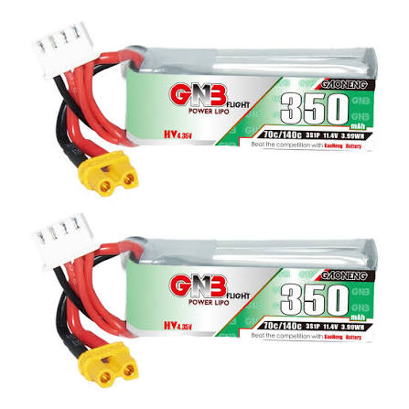
https://www.gaoneng.shop/products/gaoneng-gnb-lihv-3s-11.4v-350mah-70c-xt30-lipo-battery
Buck Converter
MP1584
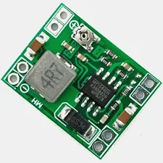
Buying Link - https://quartzcomponents.com/products/ultra-small-size-dc-dc-step-down-power-supply-module-3a-adjustable-buck-converter
Mini – 360
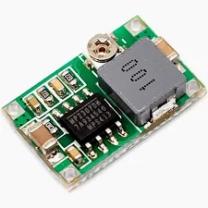
Buying Link - https://robu.in/product/mini-360-step-down-buck-converter-power-module/?gad_source=1&gad_campaignid=17416544847&gbraid=0AAAAADvLFWetfw8aeHukqJyx0hKrSuidA&gclid=CjwKCAjwl97RBhBWEiwAa9rbXVA6BIMKF19pQCvdulW9MSrOkY_w8scMH_9iMYSxmLNM8c-GrKnvdBoCNgEQAvD_BwE

XL4015 5A DC-DC Step Down Adjustable Power Supply Buck Module LED with Heatsink
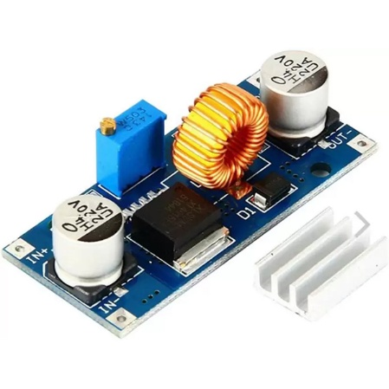
Specifications:
- Input voltage range: 4V-38V DC
- Output voltage range: 1.25V-36V DC adjustable.
- Output current: 0-5A.
- Output power: 75W.
- High efficiency up to 96%
- The built-in thermal shutdown function
- Built-in current limit function
- In-Built output short protection function
Buying Link - https://www.google.com/aclk?sa=L&ai=DChsSEwjPg8T2zt6VAxV-qGYCHYaHD-8YACICCAEQDRoCc20&co=1&ase=2&gclid=Cj0KCQjw6_HSBhCpARIsANvVltYfg9Ms79K2HR95jJT5yv0Ak9rJz8wZKc6GWJYCCO4b0q3Wcvj7krgaAnMhEALw_wcB&cid=CAASugHkaImWGj4uQMu61PqFt0hNDFd3Kj_RsqNDfpDbpbUvi1bXUXjahOLDcxtnHDQU7ob4ewgxlcpw4-Zb3AgDRYIbMz2n2OsFK4Sf3yuvtxpidDGqYlAYRfCzYLMO8As-tjs9KNRsXz8BMdZnoOCMOgzTvEA-Lc9zNJJAxPFK2omFBkSh0RJUyTs95sRNSMXcom9N1zYDfy4Hj7aBEwJaGi_orrsxD6UChNjAlsN_1ewc2RKcECRE0iOx4Ys&cce=2&category=acrcp_v1_32&sig=AOD64_38xt6rcstSvvtJnznW4_uuWJdx3w&ctype=5&q=&nis=4&ved=2ahUKEwiv27v2zt6VAxX_SmwGHWwlD1sQ5bgDKAB6BAgLEBA&adurl=

Motors :
N20-6V-600 Rpm Micro Metal Gear Motor without encoder
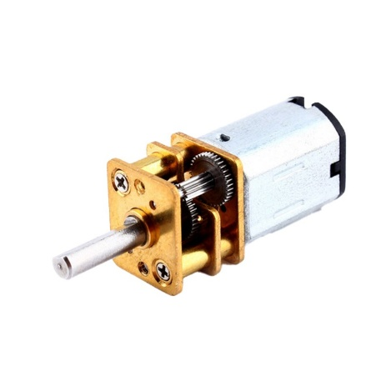
Buying -https://www.google.com/aclk?sa=L&ai=DChsSEwjpgdqKzt6VAxUurWYCHcrUCzgYACICCAEQChoCc20&co=1&ase=2&gclid=Cj0KCQjw6_HSBhCpARIsANvVltaBzMes4ina6oBaRrsk-xPdh-57sec9JNpLk8sO4n092sveSSI8GawaAljwEALw_wcB&cid=CAAS3QHkaPWrjGgLJWkP8rrhgKhG72Xykm5pQ0EFoAUnk_2RnnrE32dp5kiQGK7pVuOsfBPL4Yqy2vz49NpZvcwQX46q7P28pzeunzGlKEVsuvCU5HhLbkNL6ckUHxPUzZqaH3xgingmte0_8Y4GH-Ibg4E7OhRVk8fgoYHsJRZ7UYnKJb6QJpteUePZIwJ_dUj9q-bnYwPvVArM9B6Hfsg4HomPtDNFzOrptIysrgaFndQattPKYM4s370m2K8TuXKrbFl78i2bVai9fRC31cmJuGAGlHLtchAKF6sHhdUp0w&cce=2&category=acrcp_v1_32&sig=AOD64_0-F4QtEtDNUbShqk7lyEp4wC83uw&ctype=5&q=&nis=4&ved=2ahUKEwj_r9SKzt6VAxVGT2wGHUtxCLMQ5bgDKAB6BAgKECU&adurl=

N20 6V 250RPM Micro Metal Gear Motor with Encoder
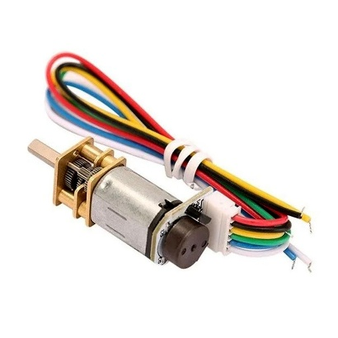
Buying - https://www.google.com/aclk?sa=L&ai=DChsSEwjBt_W42d6VAxWwgUsFHdwNKVoYACICCAEQARoCc2Y&co=1&ase=2&gclid=Cj0KCQjw6_HSBhCpARIsANvVltYWrYtKT5nJ1j7Uc811O90QsAHKQzrELVhh-P8jd8pza8WSa-6_hvsaAuRJEALw_wcB&cid=CAASugHkaAbb6bV76_gH5nVxDYdzo0kzSULgOlwntfyAAIkxqLR9c0W9wn4Qc_M6QjeRXubTwoc-lKLQtex5cg7ycyUmT_MU5geCLmB6oKjFNbQCSydGB7ZoxFn4HgeREbWhcdCHHnhhmrtRGl_xoz97u-0BW1R5WZLnGS76c7XpWRzNPgr69wWlHYWVV2OyN870x3h811jLhbYL9ZB_K5AIXwuHR-W9M4QkYOe-_Qv_Ns7feC88ZHdANP5DX8g&cce=2&category=acrcp_v1_32&sig=AOD64_0PHeRQPwB8SVgZnuC-Q2c4Fzbngg&ctype=5&q=&nis=4&ved=2ahUKEwjqk--42d6VAxU8XWwGHVV4J8cQ9aACKAB6BAgKEBA&adurl=

2S 350mAh 70C LiPo
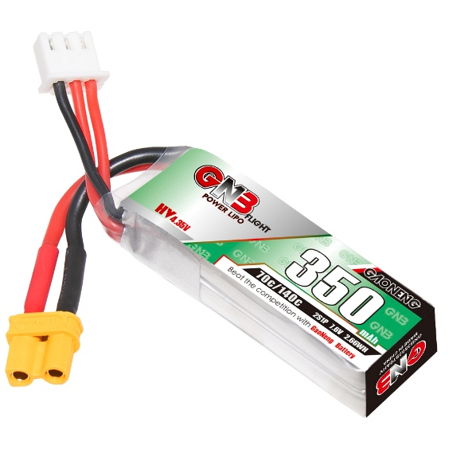

MPU6050 Gyroscope & Accelerometer Sensor Module (GY-521) – 6-Axis IMU
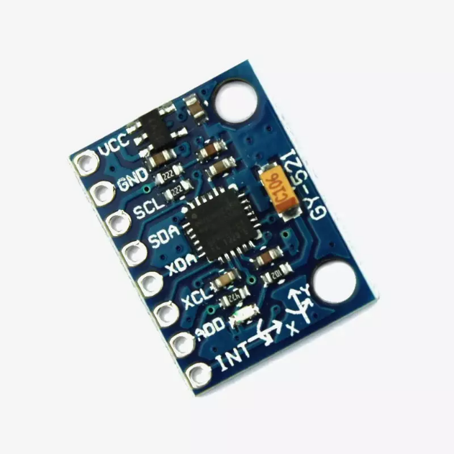
- Sensor IC: MPU6050 (also referred as GY-521)
- SKU:YTX25262014
- Sensing Axes: 6-Axis – 3-Axis Gyroscope + 3-Axis Accelerometer (MEMS)
- Supply Voltage (VCC): 3V – 5V DC
- Communication Interface: I2C (up to 400kHz Fast Mode)
- I2C Address: 0x68 (default) / 0x69 (AD0 HIGH) – Configurable
- ADC Resolution: 16-bit built-in ADC (high accuracy)
- Digital Motion Processor: Built-in DMP (offloads MCU processing)
- Temperature Sensor: Built-in onboard temperature sensor
- Auxiliary I2C: XDA / XCL pins for external sensor (e.g. magnetometer – 9-axis)
- Interrupt Pin: INT – FIFO buffer full indicator
- Output Type: Digital – I2C data frames (acceleration, gyro, temperature)
- Arduino Pins: SDA → A4, SCL → A5
- Compatibility: Arduino, ESP32, ESP8266, Raspberry Pi, STM32
Buying Link - https://www.yantronix.in/products/mpu6050-gyroscope-accelerometer-sensor-module-gy-521-%E2%80%93-6-axis-imu-with-dmp-for-arduino-raspberry-pi/1414116000002156903?srsltid=AfmBOorDHNStkDg8_hWdsdWBSwp0XPyLZqDI-a08qEbIQrgcgXs62NT0BkA

MCP3008 8-Channel 10-Bit A/D Converter with SPI Interface IC DIP-16 Package
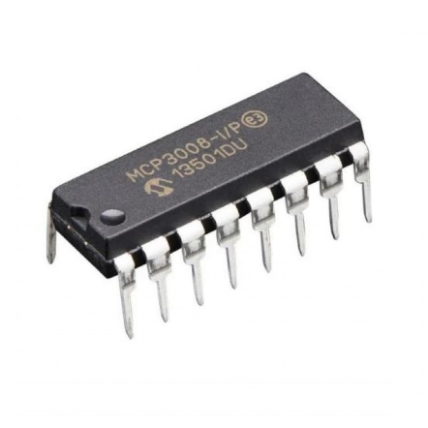
Buying link - https://www.electropi.in/mcp3008-8-channel-10-bit-a-d-converter-with-spi-interface-ic-dip-16-package

